|  |  |  |
| --- | --- | --- |
| **REQUEST FOR QUOTATION (RFQ)** | | Supplier’s Stamp/Signature: |
| Closing Date | : **15 January 2025** |
| Email Submission | : **box10@belts.com.bn** |
| BELTS Ref | : **BELTS/HCCS/RFQ/2024/074** |
| Date of Submission | : Click here to enter text. |
| Supplier/Quote Ref | : Click here to enter text. |

|  |  |
| --- | --- |
| Company Name | **Click here to enter text.** |
| Address | **Click here to enter text.** |
| Phone | Office: **Click here to enter text.** Mobile: **Click here to enter text.** |

|  |  |  |  |  |  |
| --- | --- | --- | --- | --- | --- |
| **No.** | **Item Description** | **Delivery Period** | **Qty/UoM** | **Unit Price** | **Total Price** |
| 1 | **Location:**  Janitor room - 1st floor.  **Area measurement (approx):**  197.5inch Length x 129inch Width.  **Note:**  Kindly refer to Attachment 1. | **2-3 WORKING DAYS UPON PO ISSUANCE** | **1 LOT** | **Click here to enter text.** | **Click here to enter text.** |
| 2 | **Location:**  Sales/Admin (SMS management) room - 1st floor.  **Area measurement (approx):**  318.5inch Length x 232inch Width.  **Note:**  Kindly refer to Attachment 2. | **1 LOT** | **Click here to enter text.** | **Click here to enter text.** |
| 3 | **Location:**  Hallway inside Sales/Admin (SMS management) room- 1st floor.  **Area measurement (approx):**  124.5inch Length x 89inch Width.  **Note:**  Kindly refer to Attachment 3. | **1 LOT** | **Click here to enter text.** | **Click here to enter text.** |
| 4 | **Location:**  Sales/Admin (SMS management) room -  1st floor **Area A.**  **Area measurement (approx):**  318.5inch Length x 232inch Width.  **Note:**  Kindly refer to Attachment 4. | **1**  **LOT** | **Click here to enter text.** | **Click here to enter text.** |
| 5 | **Location:**  Sales/Admin (SMS management) room-  1st floor **Area B.**  **Area measurement (approx):**  318.5inch Length x 232inch Width.  **Note:**  Kindly refer to Attachment 5. | **1 LOT** | **Click here to enter text.** | **Click here to enter text.** |
| 6 | **Location:**  Sales/Admin (SMS management) room-  1st floor **Area C.**  **Area measurement (approx):**  318.5inch Length x 232inch Width.  **Note:**  Kindly refer to Attachment 6. | **1 LOT** | **Click here to enter text.** | **Click here to enter text.** |
| 7 | **Location:**  CCTV room -1st floor.  **Area measurement (approx):**  171inch Length x 106inch Width.  **Note:**  Kindly refer to Attachment 7. | **1 LOT** | **Click here to enter text.** | **Click here to enter text.** |
| 8 | **Location:**  Support staff room- 1st floor.  **Area measurement (approx):**  170inch Length x 114inch Width.  **Note:**  Kindly refer to Attachment 8. | **1 LOT** | **Click here to enter text.** | **Click here to enter text.** |
| 9 | **Location:**  Procurement office – Area A.  **Area measurement (approx):**  258inch x 264inch  **Note:**  Kindly refer to Attachment 9. | **1 LOT** | **Click here to enter text.** | **Click here to enter text.** |
| 10 | **Location:**  Procurement office – Area B.  **Area measurement (approx):**  360inch x 222inch  **Note:**  Kindly refer to Attachment 10. |  | **1 LOT** | **Click here to enter text.** | **Click here to enter text.** |
| 11 | **Location:**  Procurement office – Area C.  **Area measurement (approx):**  72inch x 48inch  **Note:**  Kindly refer to Attachment 11. |  | **1 LOT** | **Click here to enter text.** | **Click here to enter text.** |
| 12 | **Location:**  Procurement office – Assistant Head of procurement room.  **Area measurement (approx):**  172inch x 116inch |  | **1 LOT** | **Click here to enter text.** | **Click here to enter text.** |
| 13 | **Location:**  Procurement office – Head of procurement room.  **Area measurement (approx):**  114inch x 171inch |  | **1**  **LOT** | **Click here to enter text.** | **Click here to enter text.** |
| 14 | **Location:**  Procurement office – Filing room.  **Area measurement (approx):**  414inch x 180inch  **Note:**  Kindly refer to Attachment 12. |  | **1 LOT** | **Click here to enter text.** | **Click here to enter text.** |
| 15 | **Location:**  Storeroom – Near Sales Admin (SMS Management room).  **Area measurement (approx):**  536inch x 270inch  **Note:**  Kindly refer to Attachment 13. |  | **1**  **LOT** | **Click here to enter text.** | **Click here to enter text.** |
|  | **Note:**   * **Scope of work for only item number 1:**  1. To hack and dismantle existing floor tiles and debris to contractor own dumping area complete with proper housekeeping. 2. To supply and install homogenous **floor tiles** using approved adhesive complete with levelling existing floor.  * **Scope of work for item number 2 until 15:**  1. To hack and dismantle existing floor tiles and debris to contractor own dumping area complete with proper housekeeping. 2. To supply and install **carpet tiles** using approved adhesive complete with levelling existing floor.  * **The address is at:**   BELTS Medical Supply Chain (MSC), Spg 433, Rimba Highway, Kg. Madaras.   * For any site visit purposes kindly e-Mail your date & time schedule to [admincorp@belts.com.bn](mailto:admincorp@belts.com.bn) * For any questions or enquiries kindly e-Mail directly to rfq_enquiry@belts.com.bn * Contractors must implement safety measures to protect workers and the public during installation/delivery work. * Vendors/contractors must adhere to regulatory SHENA safety rules and regulations. * Awarded vendor for this RFQ must send us with a detailed work plan/methodology of work, Risk Assessment Management System (RAMS) complete with person in charge details, emergency plan, and any other supporting documents such as Material Safety Data Sheet (MSDS), daily toolbox talk etc. * We will issue our Permit To Work (PTW) only once your RAMS have been approved. | | | | |

|  |  |  |  |
| --- | --- | --- | --- |
| **MANDATORY**  Suppliers are to provide with the Packaging Dimension, Measurement & Weight - in Standard measurement in Meter, Feet, Inches, Cm, Mm, Kg, GM | | **TOTAL PRICE** | **Click here to enter text.** |
| Freight Term (EXW,CIF,ETC) | | | **Click here to enter text.** |
| Freight Charges (IF APPLICABLE) | | | **Click here to enter text.** |
| Any other charges please state | | | **Click here to enter text.** |
| **GRAND TOTAL** | | | **Click here to enter text.** |
| Currency Code : | **BND** | | |
| Price Validity  (Minimum 9 Months) : | **Click here to enter text.** | | |
| Payment Terms : | **30 DAYS CREDIT** | | |
| Warranty : | **Click here to enter text.** | | |
| Mode of Delivery : | **Click here to enter text.** | | |
| Delivery Period : | **Click here to enter text.** | | |
| Country of Manufactured : | **Click here to enter text.** | | |
| Remarks: | **Click here to enter text.** | | |

**ATTACHMENT 1:**

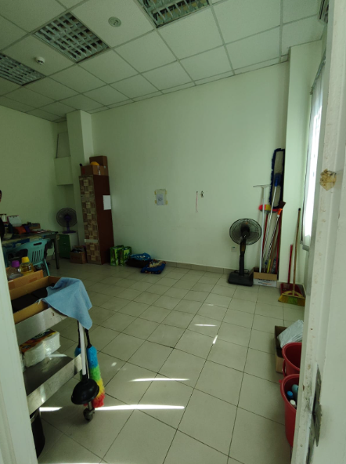

**Janitor room.**

**ATTACHMENT 2:**

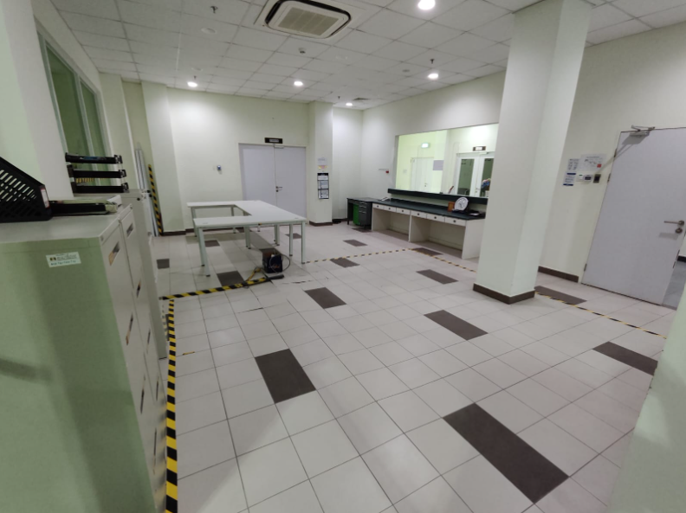

**Sales/Admin (SMS management) room.**

**ATTACHMENT 3:**

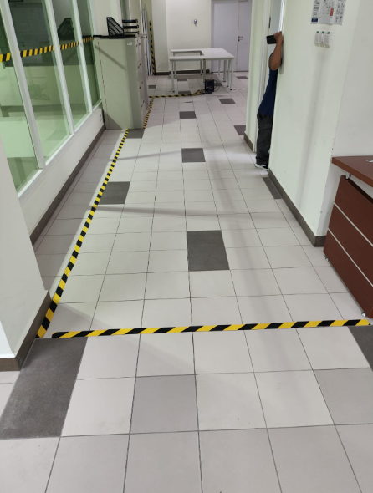

**Hallway Sales/Admin (SMS management room).**

**ATTACHMENT 4:**

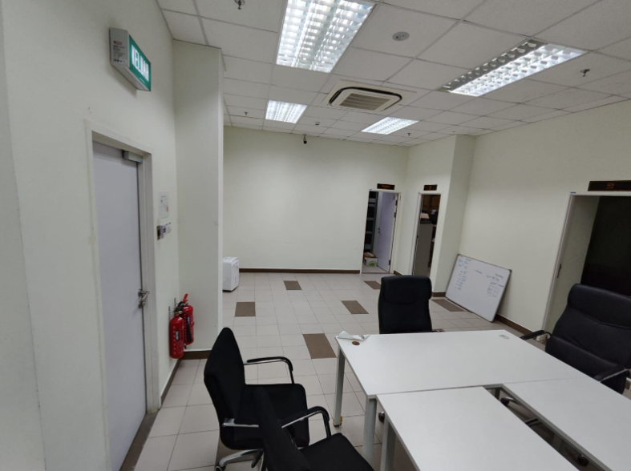

**Sales/Admin SMS management room - Area A.**

**ATTACHMENT 5:**

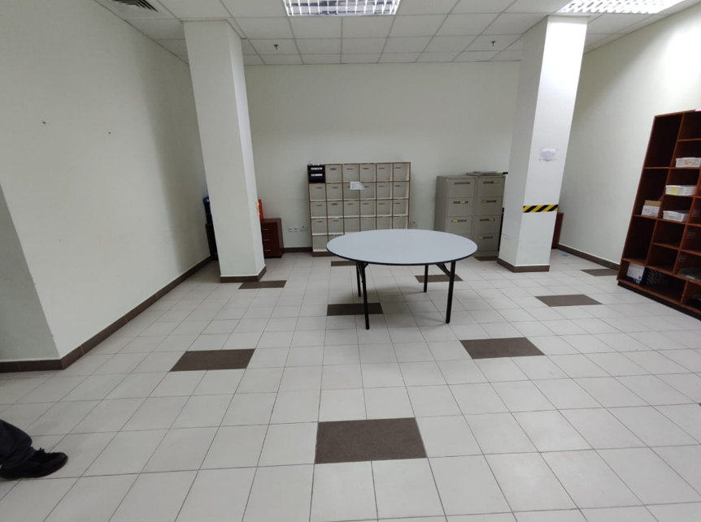

**Sales/Admin SMS management room - Area B (old picture).**

**ATTACHMENT 6:**

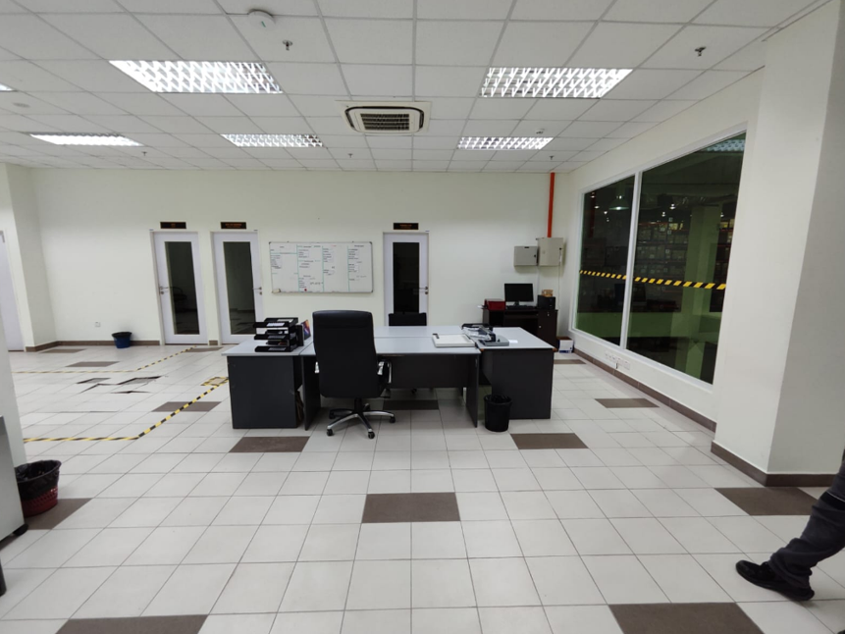

**Sales/Admin SMS management room - Area C (old picture).**

**ATTACHMENT 7:**

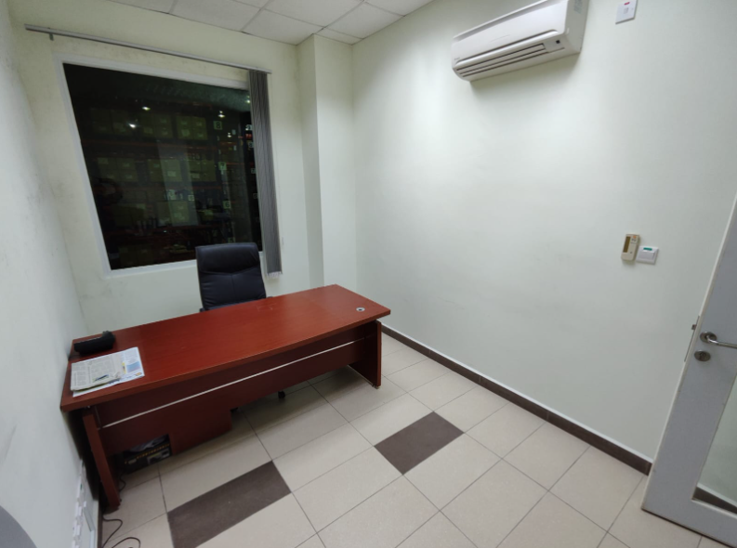

**CCTV room.**

**ATTACHMENT 8:**

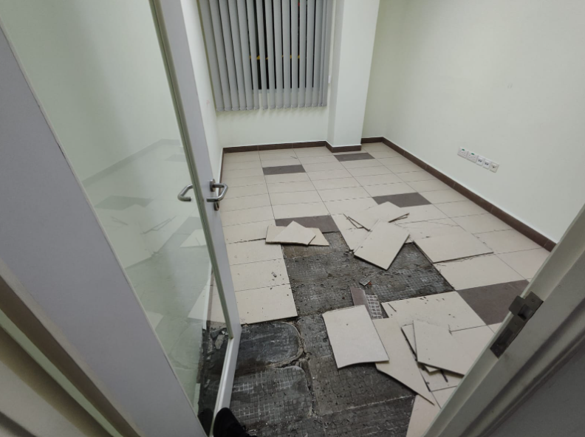

**Support staff room.**

**ATTACHMENT 9:**

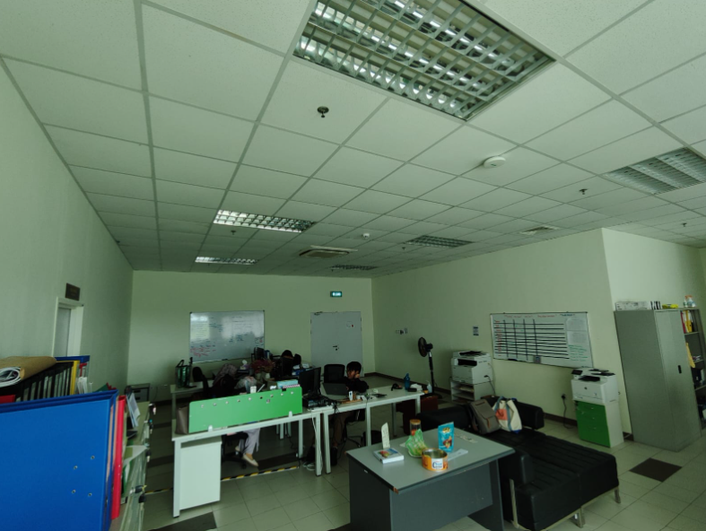

**Procurement office – Area A**

**ATTACHMENT 10:**

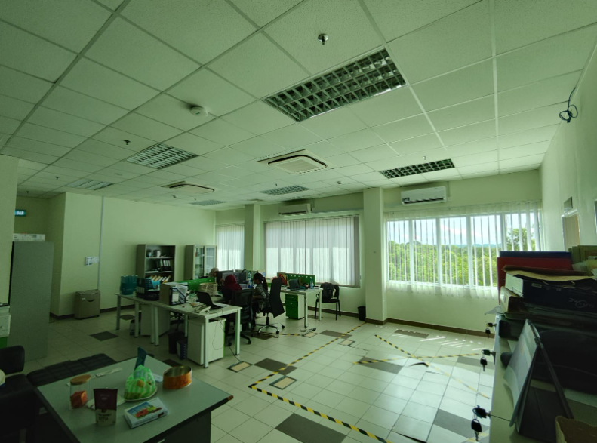

**Procurement office – Area B**

**ATTACHMENT 11:**

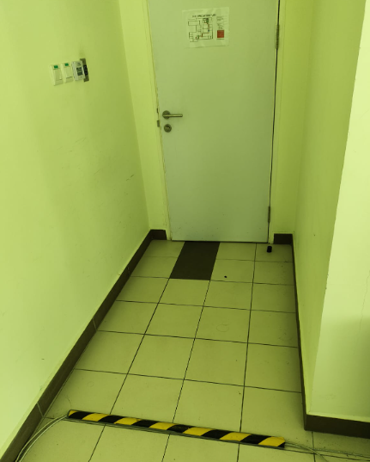

**Procurement Office – Area C**

**ATTACHEMENT 12:**

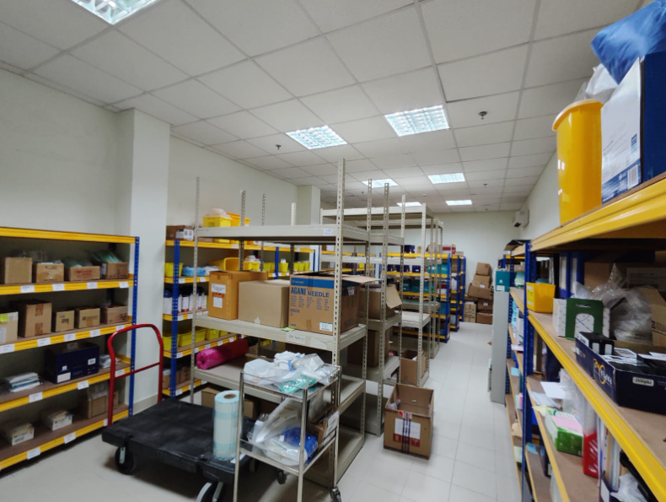

**Procurement office (filing room).**

**ATTACHMENT 13:**

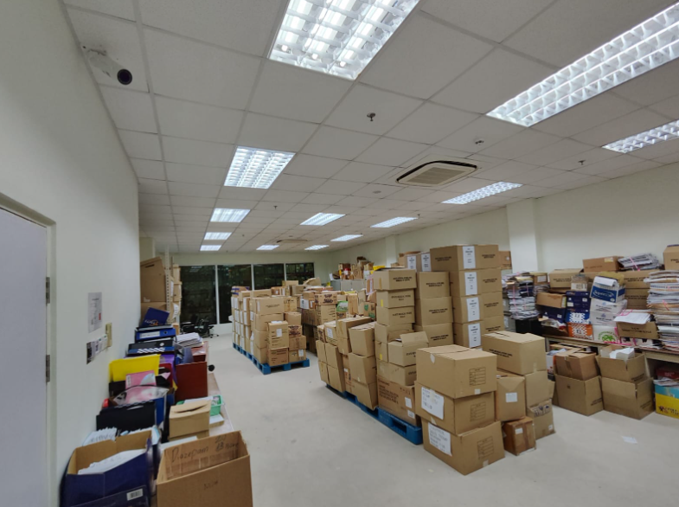

**Storeroom (near sales/admin office area).**