|  |  |  |
| --- | --- | --- |
| **REQUEST FOR QUOTATION (RFQ)** | | Supplier’s Stamp/Signature: |
| Closing Date | : **23 January 2025** |
| Email Submission | : **box10@belts.com.bn** |
| BELTS Ref | : **BELTS/HCCS/RFQ/2025/004** |
| Date of Submission | : Click here to enter text. |
| Supplier/Quote Ref | : Click here to enter text. |

|  |  |
| --- | --- |
| Company Name | **Click here to enter text.** |
| Address | **Click here to enter text.** |
| Phone | Office: **Click here to enter text.** Mobile: **Click here to enter text.** |

|  |  |  |  |  |  |
| --- | --- | --- | --- | --- | --- |
| **No.** | **Item Description** | **Delivery Period** | **Qty/UoM** | **Unit Price** | **Total Price** |
| 1 | **To supply and deliver:**  **New/used (must be in-stock)** Heavy duty open board plastic pallets for use with forklift & manual pallet jack.  Kindly refer to **Attachment 1** below for reference of the pallet jack with steel tubes insert and 2 clear openings.  **Material:**  100% Virgin HDPE  **Colour:**  Blue with steel tubes insert.  **Static load:**  4000 KG  **Dynamic load:**  1500 KG  **Racking load:**  2000 KG  **Size:**  L 1200mm x W 1000mm x H 1500mm | **2-3 WORKING DAYS UPON PURCHASE ORDER (PO) ISSUANCE** | **100 PCS** | **Click here to enter text.** | **Click here to enter text.** |
|  | Note:   * You may also provide quotations for various other similar types of plastic pallets (must be in-stock) and at least meet the minimum requirement of our racking specifications. Please refer to Attachment 2 for more details. * Kindly do provide also product catalogue details of the pallets. * Delivery to BELTS Medical Supply Chain (MSC), Spg 433, Rimba Highway, Kg. Madaras. * For any site visit purposes kindly e-Mail your date & time schedule to [admincorp@belts.com.bn](mailto:admincorp@belts.com.bn) * For any questions or enquiries kindly e-Mail directly to enquiry@belts.com.bn * Contractor must implement safety measures to protect workers and the public during installation/delivery work. | | | | |

|  |  |  |
| --- | --- | --- |
| **MANDATORY**  Suppliers are to provide with the Packaging Dimension, Measurement & Weight - in Standard measurement in Meter, Feet, Inches, Cm, Mm, Kg, GM | **TOTAL PRICE** | **Click here to enter text.** |
| Freight Term (EXW,CIF,ETC) | | **Click here to enter text.** |
| Freight Charges (IF APPLICABLE) | | **Click here to enter text.** |
| Any other charges please state | | **Click here to enter text.** |
| **GRAND TOTAL** | | **Click here to enter text.** |

|  |  |
| --- | --- |
| Currency Code : | **BND** |
| Price Validity  (Minimum 9 Months) : | **Click here to enter text.** |
| Payment Terms : | **30 DAYS CREDIT** |
| Warranty : | **Click here to enter text.** |
| Mode of Delivery : | **Click here to enter text.** |
| Delivery Period : | **Click here to enter text.** |
| Country of Manufactured : | **Click here to enter text.** |
| Remarks: | **Click here to enter text.** |

**ATTACHMENT 1**

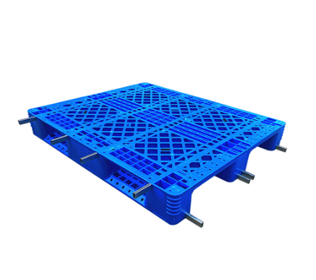

**ATTACHMENT 2**

