|  |  |  |
| --- | --- | --- |
| **REQUEST FOR QUOTATION (RFQ)** | | Supplier’s Stamp/Signature: |
| Closing Date | : **27 November 2024** |
| Email Submission | : **box3@belts.com.bn** |
| BELTS Ref | : **BELTS/HSE/RFQ/2024/001** |
| Date of Submission | : Click here to enter text. |
| Supplier/Quote Ref | : Click here to enter text. |

|  |  |
| --- | --- |
| Company Name | **Click here to enter text.** |
| Address | **Click here to enter text.** |
| Phone | Office: **Click here to enter text.** Mobile: **Click here to enter text.** |

|  |  |  |  |  |  |
| --- | --- | --- | --- | --- | --- |
| **No.** | **Item Description** | **Delivery Period** | **Qty/UoM** | **Unit Price** | **Total Price** |
| 1 | **To Supply and Install Safety Signages for BELTS Building and Premises**  **Scope of work:**  **1. General safety signage**  **1.1 Information Sign**: Assembly point (for Setia Kenangan) to replace the faded signage for HQ.  Size A3 for 1 signages.  **1.2 Information Sign:** First Aid for all sites.  Size A4 for 1 signages.  **1.3 Mandatory Sign:** PPE must be worn for ES, MSC, EHS.  Size A4 for 15 signages.  **1.4 Mandatory Sign:** Housekeeping for relevant sites.  Size A4 for 15 signages.  **1.5 Mandatory Sign:** Clear from obstruction for ES, MSC, HQ. Size A4 for 10 signages.  **1.6 Information Sign:** Temporary Storage Area, PAJ, ES, MSC. Size A4 for 10 signages.  **1.7 Prohibition Sign**: Authorized Personnel Only for restricted and sensitive area.  Size A4 for 15 signages.  **1.8 Warning Sign:** Flammable Material for ES and EHS.  Size A4 for 10 signages.  **1.9 Warning Sign:** No Smoking. for ES, EHS, MSC,  Size A4 for 10 signages.  **1.10Warning Sign:** Harmful Fumes for ES.  Size A4 for 10 signages.  **1.11** **Warning Sign:** Pressurized Cylinder for ES and TSC.  Size A4 for 10 signages.  **1.12** **Warning Sign:** Explosive Material for EHS.  Size A3 for 10 signages.  The design should be standardized using the attached design.  The **measurements size** should be as below:  **A4**: 21 cm by 29.7 cm  **A3**: 29.7 cm by 42 cm  **All material** will be **acrylic** and each of the signage must be readily installed with **3M stickers** for easy installation.  **2. Standing signage with labels:**  **2.1** Caution Slippery Floor Yellow Color for MSC and ES for 2 standees (example as attached)  **Size: 300MM x 600MM**  **Kindly refer to Attachment 1 for more info.** | **2-3 WORKING DAYS UPON PO ISSUANCE** | **1 LOT** | **Click here to enter text.** | **Click here to enter text.** |
|  | Note:   * For any site visit purposes kindly e-Mail your date & time schedule to hse@belts.com.bn * For any questions or enquiries kindly e-Mail directly to rfq_enquiry@belts.com.bn * Contractor must implement safety measures to protect workers and the public during installation/delivery work. * Vendors/contractors must adhere to regulatory SHENA safety rules and regulations. * Awarded vendor for this RFQ must send us with a detailed work plan/methodology of work, Risk Assessment Management System (RAMS) complete with person in charge details, emergency plan, and any other supporting documents such as Material Safety Data Sheet (MSDS), daily toolbox talk etc. * If Required, HSE unit will issue out Permit To Work (PTW) only once your RAMS have been approved. | | | | |

|  |  |  |  |
| --- | --- | --- | --- |
| **MANDATORY**  Suppliers are to provide with the Packaging Dimension, Measurement & Weight - in Standard measurement in Meter, Feet, Inches, Cm, Mm, Kg, GM | | **TOTAL PRICE** | **Click here to enter text.** |
| Freight Term (EXW,CIF,ETC) | | | **Click here to enter text.** |
| Freight Charges (IF APPLICABLE) | | | **Click here to enter text.** |
| Any other charges please state | | | **Click here to enter text.** |
| **GRAND TOTAL** | | | **Click here to enter text.** |
| Currency Code : | **BND** | | |
| Price Validity  (Minimum 9 Months) : | **Click here to enter text.** | | |
| Payment Terms : | **30 DAYS CREDIT** | | |
| Warranty : | **Click here to enter text.** | | |
| Mode of Delivery : | **Click here to enter text.** | | |
| Delivery Period : | **Click here to enter text.** | | |
| Country of Manufactured : | **Click here to enter text.** | | |
| Remarks: | **Click here to enter text.** | | |

**ATTACHMENT 1:**

1.1 1.2

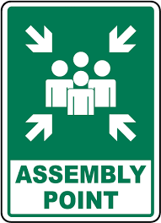

*

*

1.8 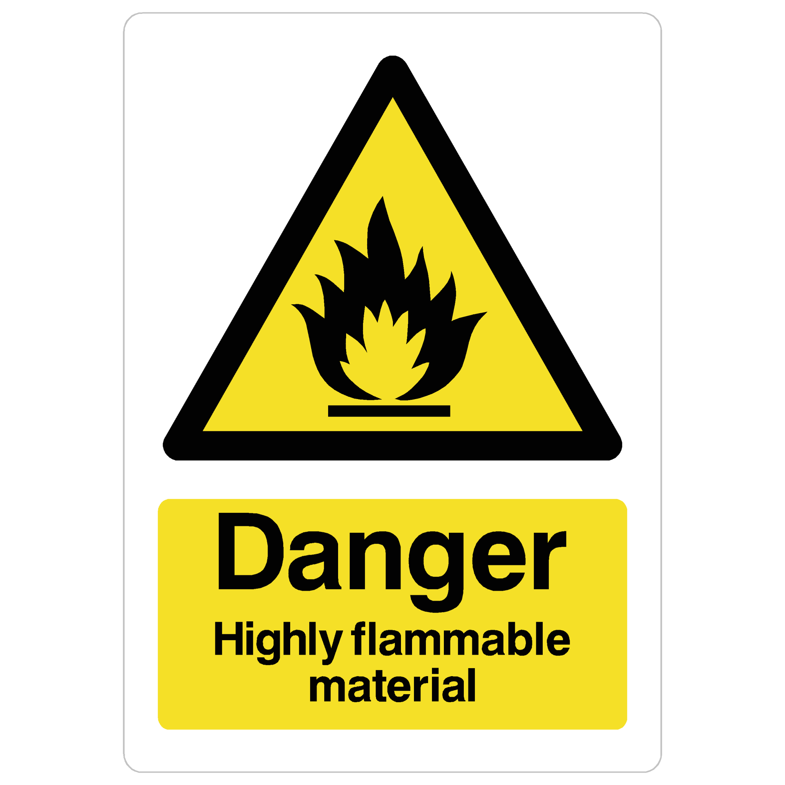 1.9 **No smoking sign**

*

1.11 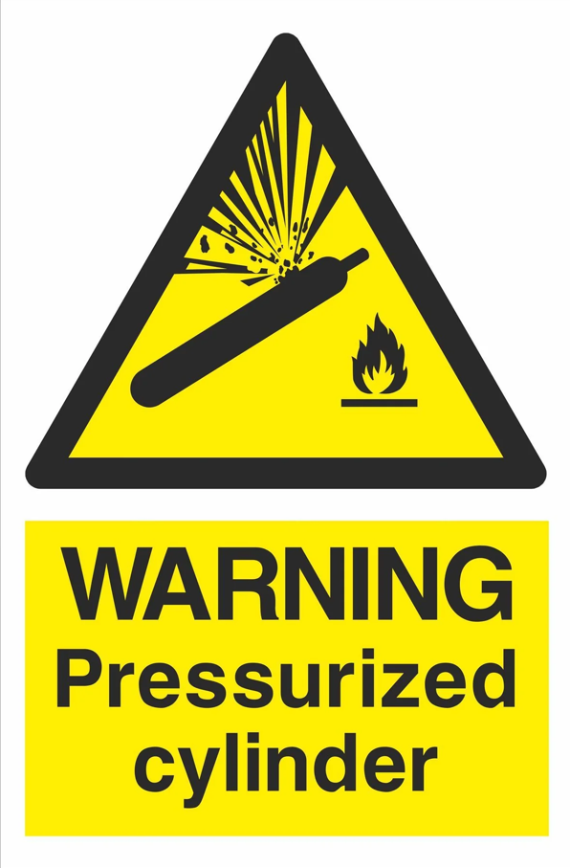*

2.1

