08
REQUEST FOR QUOTATION (RFQ) |  | Supplier’s Stamp/Signature:
Closing Date | : 13 November 2024
Email Submission | : box3@belts.com.bn
BELTS Ref | : BELTS/TRN/TSC/2024/RFQ/40
Date of Submission | : Click here to enter text.
Supplier/Quote Ref | : Click here to enter text.

Company Name | Click here to enter text.
Address | Click here to enter text.
Phone | Office: Click here to enter text. Mobile: Click here to enter text.

No. | Item Description | Delivery Period | Qty/UoM | Unit Price | Total Price
 | To supply and deliver tools appliances for TSC maintenance activities. |  |  | Click here to enter text. | Click here to enter text.
1 | Hand Cleaner with scrubs  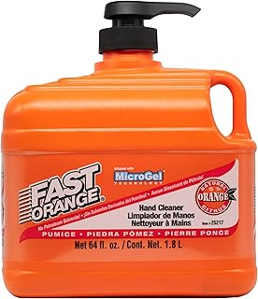 | Nov 2024 | 1 EA
2 | 4 Tier - A4 Drawer Case  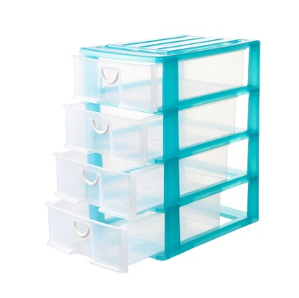 |  | 3 EA
3 | 20 Drawer Parts Storage – 5 X 4 rows  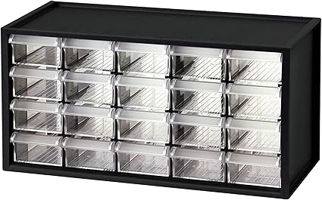 |  | 2 EA
4 | Electrical Tape – Black  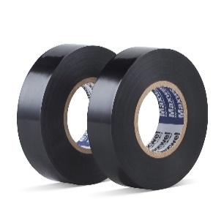 |  | 5 EA
5 | Cable Tie 6”X3.6 (150x3.6mm)   |  | 2 EA
6 | Slotted and Phillips Screwdriver set – 10 pcs  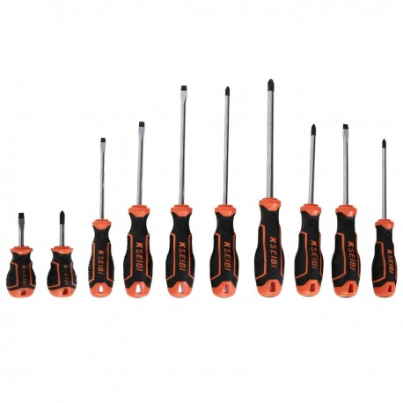 |  | 1 EA
7 | 4 or 5 Drawers Steel Wheeled Tool Trolley  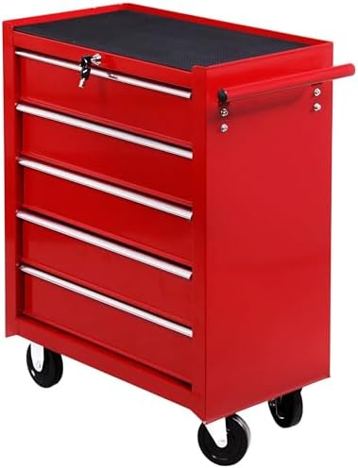 |  | 1 EA
8 | Heavy Duty Cable Reel (Power Extension) – 50meter  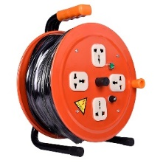 |  | 1 EA
9 | Rechargeable Computer Vacuum Cleaner   |  | 1 EA
10 | Velcro Tape Double Sided – 38mm x 25m  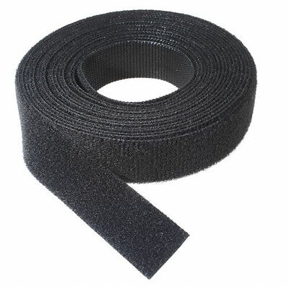 |  | 1 EA
11 | PVC Storage Bin Red (300*450*177mm)   |  | 4 EA
12 | PVC Storage Bin Red (200*450*177mm) |  | 6 EA
13 | PVC Storage Bin Red (195*348*150mm) |  | 3 EA
14 | PVC Storage Bin Red (150*245*150mm) |  | 10 EA
15 | Heavy Duty Security Padlock (E.g. Abloy / Unity)  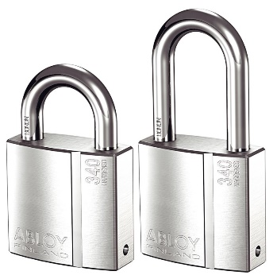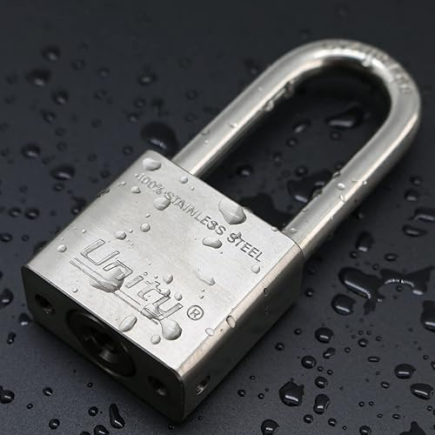 |  | 7 EA
16 | Plastic Ziplock 26x41 cm  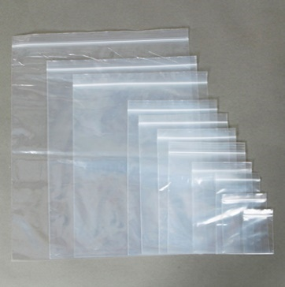 |  | 30 EA

17 | Plastic Ziplock 23x36 cm | Nov 2024 | 30 EA
18 | Plastic Ziplock 16x24 cm |  | 80 EA
19 | Plastic Ziplock 9x13 cm |  | 80 EA
20 | Plastic Ziplock 11x25 cm |  | 80 EA
21 | Plastic Ziplock 10x15 cm |  | 80 EA
22 | Plastic Ziplock 8x12 cm |  | 80 EA

MANDATORY  Suppliers are to provide with the Packaging Dimension,  Measurement & Weight - in Standard measurement in Meter, Feet,  Inches, Cm, Mm, Kg, GM | TOTAL PRICE | Click here to enter text.
Freight Term (EXW,CIF,ETC) |  | Click here to enter text.
Freight Charges (IF APPLICABLE) |  | Click here to enter text.
Any other charges please state |  | Click here to enter text.
GRAND TOTAL |  | Click here to enter text.

Currency Code : | BND
Price Validity  (Minimum 9 Months) : | Click here to enter text.
Payment Terms : | 30 DAYS CREDIT
Warranty : | Click here to enter text.
Mode of Delivery : | Click here to enter text.
Delivery Period : | Click here to enter text.
Country of Manufactured : | Click here to enter text.
Remarks: | Click here to enter text.

