|  |  |  |
| --- | --- | --- |
| **REQUEST FOR QUOTATION (RFQ)** | | Supplier’s Stamp/Signature: |
| Closing Date | : **02 October 2024** |
| Email Submission | : **box3@belts.com.bn** |
| BELTS Ref | : **BELTS/HCCS/RFQ/2024/065** |
| Date of Submission | : Click here to enter text. |
| Supplier/Quote Ref | : Click here to enter text. |

|  |  |
| --- | --- |
| Company Name | **Click here to enter text.** |
| Address | **Click here to enter text.** |
| Phone | Office: **Click here to enter text.** Mobile: **Click here to enter text.** |

|  |  |  |  |  |  |
| --- | --- | --- | --- | --- | --- |
| **No.** | **Item Description** | **Delivery Period** | **Qty/UoM** | **Unit Price** | **Total Price** |
| 1 | **Scope of work:**  To supply, repair and replace the existing pop out tiles with same/similar floor tiles.  **Location:**  Janitor room, 1st floor.  **Area measurement:**  197.5inch Length x 129inch Width.  **Note:**  Kindly refer to Attachment 1. | **2-3 WORKING DAYS UPON PO ISSUANCE** | **1 LOT** | **Click here to enter text.** | **Click here to enter text.** |
| 2 | **Scope of work:**  To supply, repair and replace the existing pop out tiles with same/similar floor tiles.  **Location:**  Sales/Admin (SMS management) room, 1st floor.  **Area measurement:**  318.5inch Length x 232inch Width.  **Note:**  Kindly refer to Attachment 2. | **1 LOT** | **Click here to enter text.** | **Click here to enter text.** |
| 3 | **Scope of work:**  To supply, repair and replace the existing pop out tiles with same/similar floor tiles.  **Location:**  Hallway inside Sales/Admin (SMS management) room, 1st floor.  **Area measurement:**  124.5inch Length x 89inch Width.  **Note:**  Kindly refer to Attachment 3. | **1 LOT** | **Click here to enter text.** | **Click here to enter text.** |
| 4 | **Scope of work:**  To supply, repair and replace the existing pop out tiles with same/similar floor tiles.  **Location:**  CCTV room, 1st floor.  **Area measurement:**  171inch Length x 106inch Width.  **Note:**  Kindly refer to Attachment 4. | **1 LOT** | **Click here to enter text.** | **Click here to enter text.** |
| 5 | **Scope of work:**  To supply, repair and replace the existing pop out tiles with same/similar floor tiles.  **Location:**  Support staff room, 1st floor.  **Area measurement:**  170inch Length x 114inch Width.  **Note:**  Kindly refer to Attachment 5. | **1 LOT** | **Click here to enter text.** | **Click here to enter text.** |
| 6 | **Scope of work:**  To supply, repair and install 2 sets (top and bottom) with new door locks.  **Location:**  SMS management and SMS procurement main entrance doors.  **Note:**  Kindly refer to Attachment 6. | **2 UN** | **Click here to enter text.** | **Click here to enter text.** |
|  | **Note:**   * To provide an optional price quotation also with carpet for line of item number 1-5. * The address is at BELTS Medical Supply Chain (MSC), Spg 433, Rimba Highway, Kg. Madaras. | | | | |
|  | Note:   * For any site visit purposes kindly e-Mail your date & time schedule to [admincorp@belts.com.bn](mailto:admincorp@belts.com.bn) * For any questions or enquiries kindly e-Mail directly to rfq_enquiry@belts.com.bn * Contractor must implement safety measures to protect workers and the public during installation/delivery work. * Vendors/contractors must adhere to regulatory SHENA safety rules and regulations. * Awarded vendor for this RFQ must send us with a detailed work plan/methodology of work, Risk Assessment Management System (RAMS) complete with person in charge details, emergency plan, and any other supporting documents such as Material Safety Data Sheet (MSDS), daily toolbox talk etc. * We will issue our Permit To Work (PTW) only once your RAMS have been approved. | | | | |

|  |  |  |  |
| --- | --- | --- | --- |
| **MANDATORY**  Suppliers are to provide with the Packaging Dimension, Measurement & Weight - in Standard measurement in Meter, Feet, Inches, Cm, Mm, Kg, GM | | **TOTAL PRICE** | **Click here to enter text.** |
| Freight Term (EXW,CIF,ETC) | | | **Click here to enter text.** |
| Freight Charges (IF APPLICABLE) | | | **Click here to enter text.** |
| Any other charges please state | | | **Click here to enter text.** |
| **GRAND TOTAL** | | | **Click here to enter text.** |
| Currency Code : | **BND** | | |
| Price Validity  (Minimum 9 Months) : | **Click here to enter text.** | | |
| Payment Terms : | **30 DAYS CREDIT** | | |
| Warranty : | **Click here to enter text.** | | |
| Mode of Delivery : | **Click here to enter text.** | | |
| Delivery Period : | **Click here to enter text.** | | |
| Country of Manufactured : | **Click here to enter text.** | | |
| Remarks: | **Click here to enter text.** | | |

**ATTACHMENT 1:**

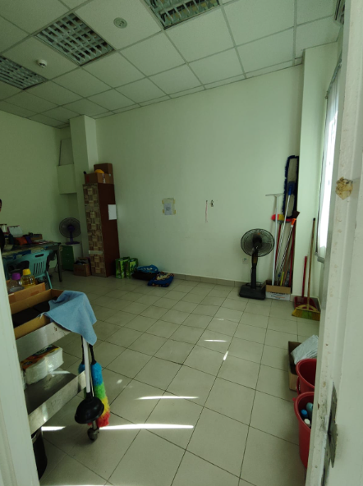

**Janitor room.**

**ATTACHMENT 2:**

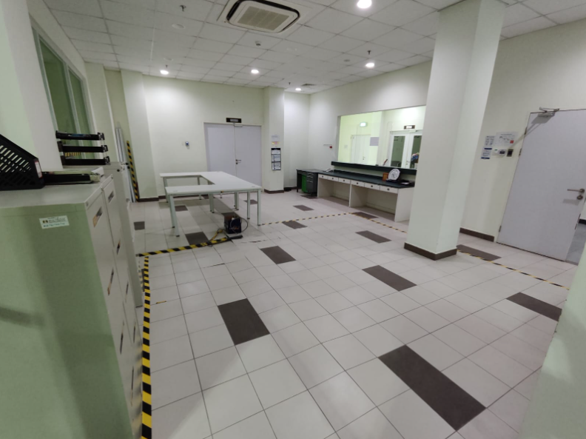

**Sales/Admin (SMS management) room.**

**ATTACHMENT 3:**

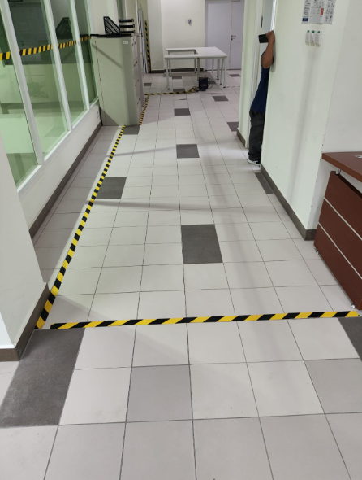

**Hallway (inside SMS management room).**

**ATTACHMENT 4:**

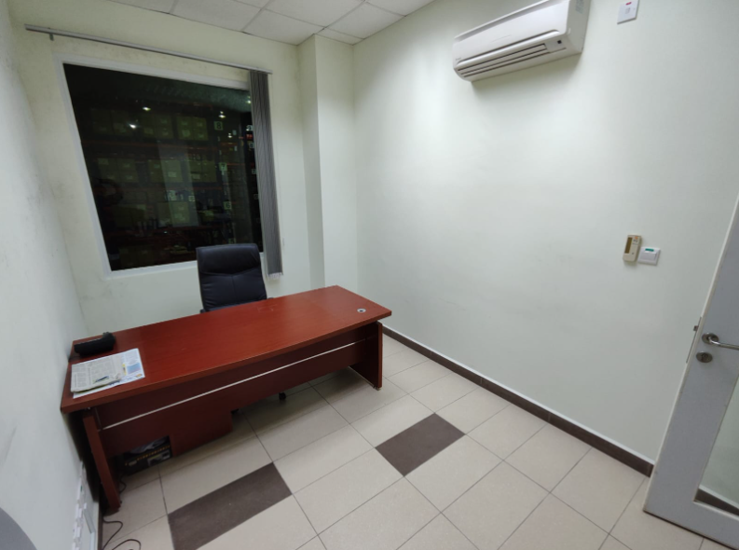

**CCTV room.**

**ATTACHMENT 5:**

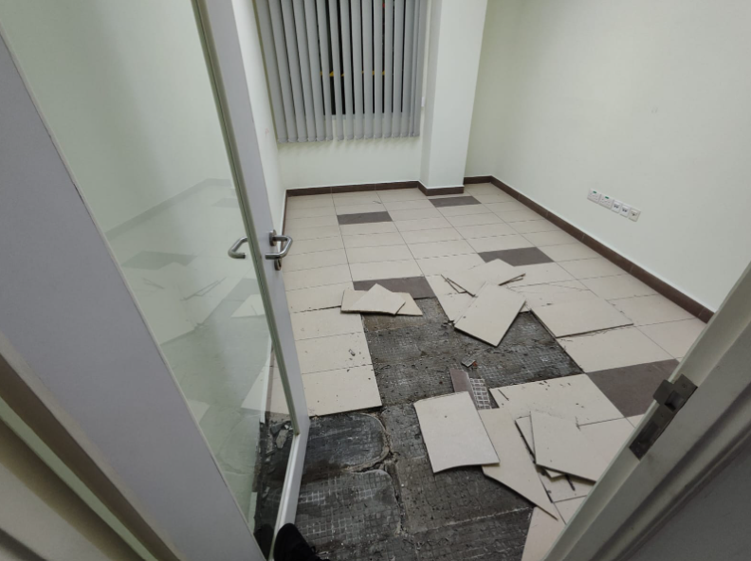

**Support staff room.**

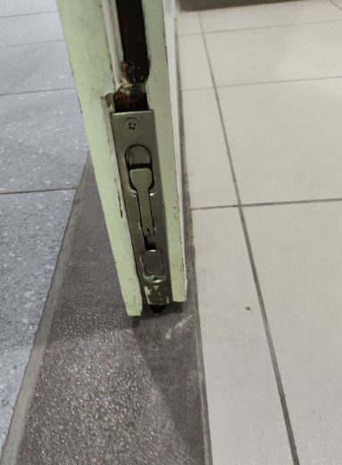**ATTACHMENT 6:**

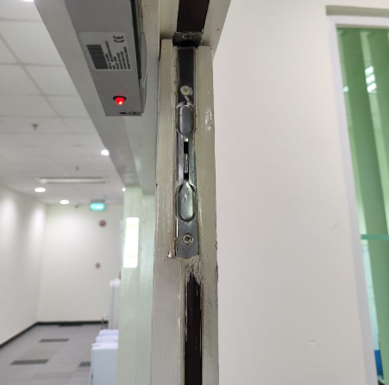

**SMS management main entrance faulty door locks.**

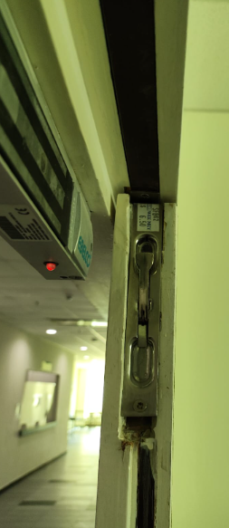

**SMS procurement main entrance faulty door locks.**