|  |  |  |
| --- | --- | --- |
| **REQUEST FOR QUOTATION (RFQ)** | | Supplier’s Stamp/Signature: |
| Closing Date | : **16 August 2024** |
| Email Submission | : **box10@belts.com.bn** |
| BELTS Ref | : **BELTS/HCCS/RFQ/2024/048** |
| Date of Submission | : Click here to enter text. |
| Supplier/Quote Ref | : Click here to enter text. |

|  |  |
| --- | --- |
| Company Name | **Click here to enter text.** |
| Address | **Click here to enter text.** |
| Phone | Office: **Click here to enter text.** Mobile: **Click here to enter text.** |

|  |  |  |  |  |  |
| --- | --- | --- | --- | --- | --- |
| **No.** | **Item Description** | **Delivery Period** | **Qty/UoM** | **Unit Price** | **Total Price** |
| 1 | To replace existing insulation sheet and chicken wire netting with new insulation sheet and chicken wire netting at deployment area.  **Measurement area:**  40m (L) x 6 m (W)  Kindly refer to **Attachment 1** below for your perusal. | **2-3 WORKING DAYS UPON PO ISSUANCE** | **1 LOT** | **Click here to enter text.** | **Click here to enter text.** |
| 2 | To clean, repair and repaint the gutters with anti-corrosion paint (black color) at deployment area.  Kindly refer to **Attachment 2** below for your perusal. | **1 LOT** | **Click here to enter text.** | **Click here to enter text.** |
| 3 | To scrap off the existing paint of steel bracing structure at deployment area and to reapply with anti-corrosion paint (black color).  Refer to **Attachment 2** below for your perusal. | **1 LOT** | **Click here to enter text.** | **Click here to enter text.** |
| 4 | To dismantle 4 units of the existing ceiling fans and to install new ceiling fan   * To supply 2 new units of:   Panasonic brand  Model no. F-56MZ2, (140 cm/56 inch) at deployment area.   * To install 2 new units of ceiling fans from BELTS existing stock.   Kindly refer to **Attachment 3** below for your perusal. | **2 UN** | **Click here to enter text.** | **Click here to enter text.** |
| 5 | To repair the roller gates and to repaint with anti-corrosion paint (black color) for   * Deployment area, main entrance roller gate only. | **1 UN** | **Click here to enter text.** | **Click here to enter text.** |
| 6 | To replace new roller gates for:   * Arena entrance (2 unit’s) * Shooting target arena (1 Unit) | **3 UN** | **Click here to enter text.** | **Click here to enter text.** |
| 7 | To replace damaged electric box at the field Arena.  **Quantity:**  10 units.  Refer to **Attachment 4** for your reference. | **10 UN** | **Click here to enter text.** | **Click here to enter text.** |
| 8 | To repair the safety nets of all Arena and install new hooks  **Note:**  Some of the safety nets which requires replacement will be provided by BELTS, completed with carabiner and cable.  Some of the pole hooks are rusty. Welding is needed to install a new hook.  Kindly refer to **Attachment 5** for your reference. |  | **1**  **LOT** | **Click here to enter text.** | **Click here to enter text.** |
|  | Note:   * For any site visit purposes kindly e-Mail your date & time schedule to [admincorp@belts.com.bn](mailto:admincorp@belts.com.bn) * For any questions or enquiries kindly e-Mail directly to rfq_enquiry@belts.com.bn * Contractor must implement safety measures to protect workers and the public during installation/delivery work. * Vendors/contractors must adhere to regulatory SHENA safety rules and regulations. * Awarded vendor for this RFQ must send us with a detailed work plan/methodology of work, Risk Assessment Management System (RAMS) complete with person in charge details, emergency plan, and any other supporting documents such as Material Safety Data Sheet (MSDS), daily toolbox talk etc. * We will issue our Permit To Work (PTW) only once your RAMS have been approved. | | | | |

|  |  |  |
| --- | --- | --- |
| **MANDATORY**  Suppliers are to provide with the Packaging Dimension, Measurement & Weight - in Standard measurement in Meter, Feet, Inches, Cm, Mm, Kg, GM | **TOTAL PRICE** | **Click here to enter text.** |
| Freight Term (EXW,CIF,ETC) | | **Click here to enter text.** |
| Freight Charges (IF APPLICABLE) | | **Click here to enter text.** |
| Any other charges please state | | **Click here to enter text.** |
| **GRAND TOTAL** | | **Click here to enter text.** |

|  |  |
| --- | --- |
| Currency Code : | **BND** |
| Price Validity  (Minimum 9 Months) : | **Click here to enter text.** |
| Payment Terms : | **30 DAYS CREDIT** |
| Warranty : | **Click here to enter text.** |
| Mode of Delivery : | **Click here to enter text.** |
| Delivery Period : | **Click here to enter text.** |
| Country of Manufactured : | **Click here to enter text.** |
| Remarks: | **Click here to enter text.** |

**ATTACHMENT 1**

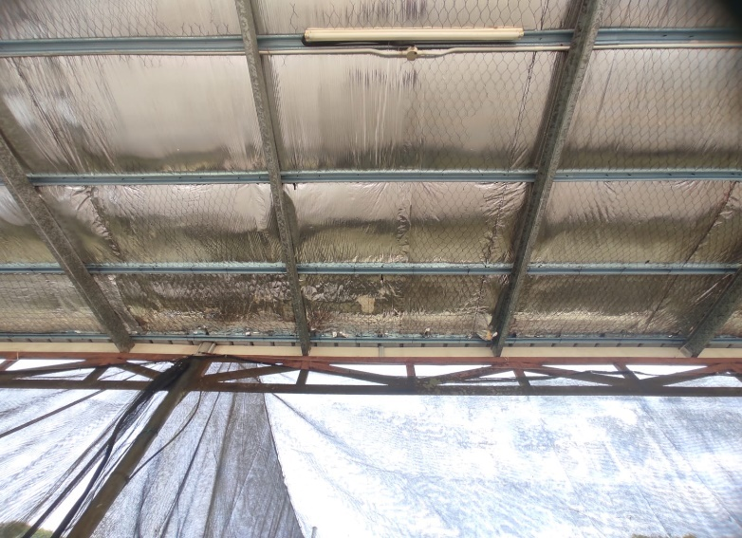

**Defective insulation sheets and chicken wire nettings.**

**ATTACHMENT 2**

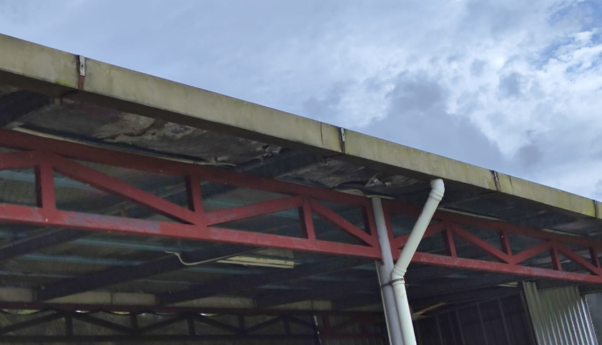

**Gutter & steel bracing structure.**

**ATTACHMENT 3**

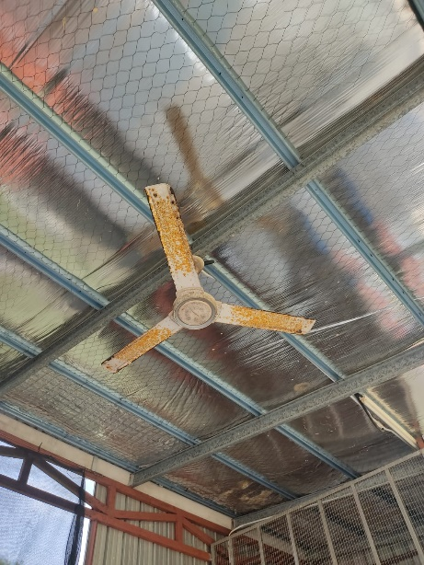

**To replace 4 units of faulty and rusty ceiling fans.**

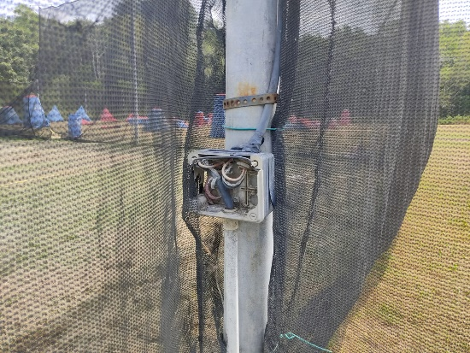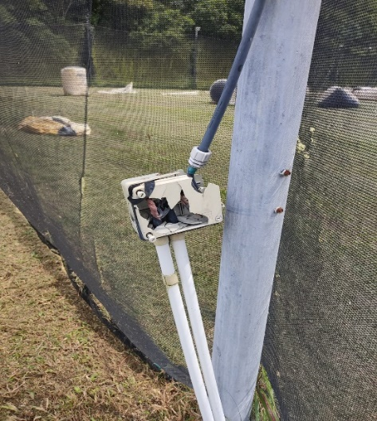**ATTACHMENT 4**

**Damaged electric box**

**ATTACHMENT 5**

Arena 1:

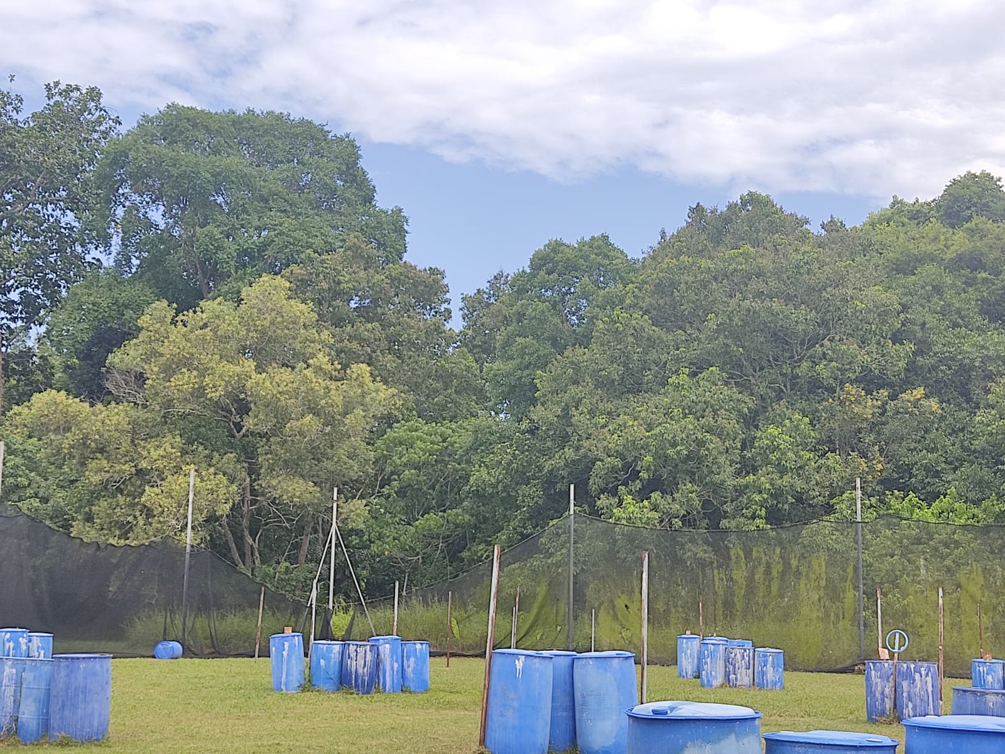

Arena 2:

