|  |  |  |
| --- | --- | --- |
| **REQUEST FOR QUOTATION (RFQ)** | | Supplier’s Stamp/Signature: |
| Closing Date | : **19 JULY 2024** |
| Email Submission | : **box10@belts.com.bn** |
| BELTS Ref | : **BELTS/HCCS/RFQ/2024/044** |
| Date of Submission | : Click here to enter text. |
| Supplier/Quote Ref | : Click here to enter text. |

|  |  |
| --- | --- |
| Company Name | **Click here to enter text.** |
| Address | **Click here to enter text.** |
| Phone | Office: **Click here to enter text.** Mobile: **Click here to enter text.** |

|  |  |  |  |  |  |
| --- | --- | --- | --- | --- | --- |
| **No.** | **Item Description** | **Delivery Period** | **Qty/UoM** | **Unit Price** | **Total Price** |
| 1 | **To supply labour, equipment and materials to construct two speed humps on the following locations situated in the BELTS MSC building area**:   1. On top of the existing zebra crossing line, in front of the security guard post.   Refer to **Attachment 1** for the exact location.   1. On top of the existing zebra crossing line on the external road, just pass the security guard post.   Refer to **Attachment 2** for the exact location.  **Specifications of the hump:**   * Material: Asphaltic concrete. * Markings: Zebra crossing white stripe pattern using road paint. * Dimensions for speed hump A: 7300mm length x 2500mm width x 30-35mm height. * Dimensions for speed hump B: 9600mm length x 2500mm width x 30-35mm height. * Shape: Trapezoidal for ease of walking for the pedestrian.     **Note:**  Kindly provide us with 2 quotation options of the ramps to be made from asphaltic concrete or pre-made ones. | **2-3 WORKING DAYS UPON PURCHASE ORDER (PO) ISSUANCE** | **1 LOT** | **Click here to enter text.** | **Click here to enter text.** |
| 2 | **To supply and install**   * New door handle of the magnetic entrance door, entrance gate near to Security guard post. * The door handle must fit into the dimension of 9” length x 2” width. * Refer to **Attachment 3** for more details. | **1 LOT** | **Click here to enter text.** | **Click here to enter text.** |
| 3 | **To repair the entrance roller gate at BELTS MSC building**  Repair must include the following:   * Replacement of the 2 damaged roller gate motors with new motor, preferably using the FAAC brand model 740. Any replacement of the motors must be compatible with existing control panels.   Refer to **Attachment 4** for more details.   * Replacement of the damaged rollers and lubricate all moving pats to ensure smooth operation.   Refer to **Attachment 5** for more details.   * To re-paint the entire roller gate to prevent further rusting using anti-corrosive undercoat and finish with metal paint. | **1 LOT** | **Click here to enter text.** | **Click here to enter text.** |
| 4 | **To supply and install new assembly signage at the centre of the car park located outside BELTS MSC building**  Refer to **Attachment 6** for the exact location point.  **Requirements**   * **Design and dimension**: Must follow the same design and dimensions as the existing assembly signage located inside the BELTS MSC building.   Refer to **Attachment 7** for more details.   * **Mounting and support:** Signage must be installed securely on a reinforcement concrete flooring with the dimension of 300mm length x 300mm width x600mm depth. | **1 LOT** | **Click here to enter text.** | **Click here to enter text.** |
|  | Note:   * The location is at BELTS Medical Supply Chain (MSC), Spg 433, Rimba Highway, Kg. Madaras. * For any site visit purposes kindly e-Mail your date & time schedule to [admincorp@belts.com.bn](mailto:admincorp@belts.com.bn) * For any questions or enquiries kindly e-Mail directly to rfq_enquiry@belts.com.bn * Contractor must conduct a site survey to determine scope of work and installation for item description number 1 – 4. * Contractor must properly dispose of all waste materials on site. * Contractor must implement safety measures to protect workers and the public during installation work. | | | | |

|  |  |  |
| --- | --- | --- |
| **MANDATORY**  Suppliers are to provide with the Packaging Dimension, Measurement & Weight - in Standard measurement in Meter, Feet, Inches, Cm, Mm, Kg, GM | **TOTAL PRICE** | **Click here to enter text.** |
| Freight Term (EXW,CIF,ETC) | | **Click here to enter text.** |
| Freight Charges (IF APPLICABLE) | | **Click here to enter text.** |
| Any other charges please state | | **Click here to enter text.** |
| **GRAND TOTAL** | | **Click here to enter text.** |

|  |  |
| --- | --- |
| Currency Code : | **BND** |
| Price Validity  (Minimum 9 Months) : | **Click here to enter text.** |
| Payment Terms : | **30 DAYS CREDIT** |
| Warranty : | **Click here to enter text.** |
| Mode of Delivery : | **Click here to enter text.** |
| Delivery Period : | **Click here to enter text.** |
| Country of Manufactured : | **Click here to enter text.** |
| Remarks: | **Click here to enter text.** |

**ATTACHMENT 1**

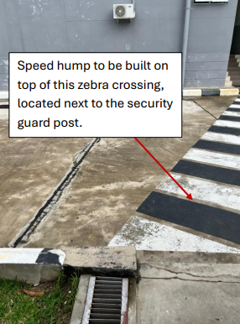

**ATTACHMENT 2**

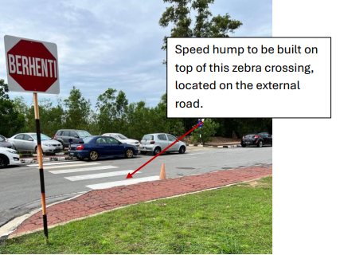

**ATTACHMENT 3**

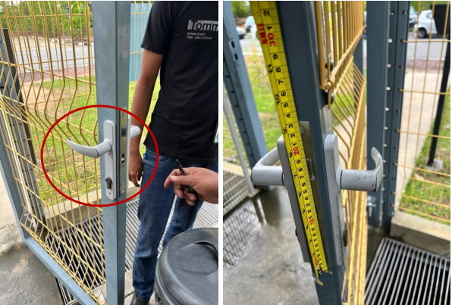

**ATTACHMENT 4**

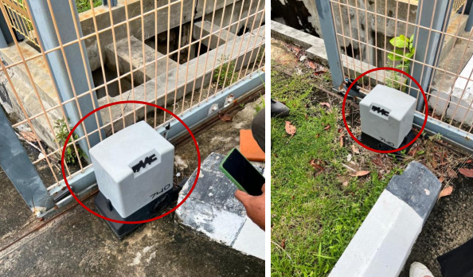

**ATTACHMENT 5**

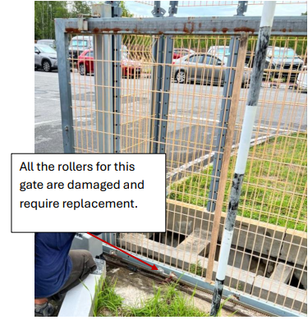

**ATTACHMENT 6**

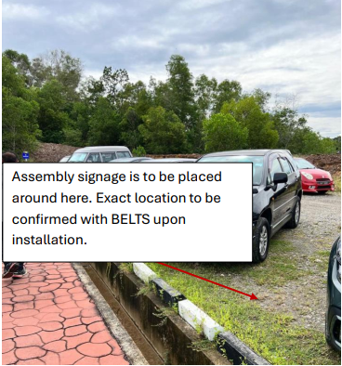

**ATTACHMENT 7**

