|  |  |  |
| --- | --- | --- |
| **REQUEST FOR QUOTATION (RFQ)** | | Supplier’s Stamp/Signature: |
| Closing Date | : **25 June 2024** |
| Email Submission | : **box2@belts.com.bn** |
| BELTS Ref | : **BELTS/HCCS/RFQ/2024/040** |
| Date of Submission | : Click here to enter text. |
| Supplier/Quote Ref | : Click here to enter text. |

|  |  |
| --- | --- |
| Company Name | **Click here to enter text.** |
| Address | **Click here to enter text.** |
| Phone | Office: **Click here to enter text.** Mobile: **Click here to enter text.** |

|  |  |  |  |  |  |
| --- | --- | --- | --- | --- | --- |
| **No.** | **Item Description** | **Delivery Period** | **Qty/UoM** | **Unit Price** | **Total Price** |
| 1 | To supply and lay 150mm thick reinforced concrete drain cover G30 with 10mm rebar (150mm c/c both way).  **Measurement:**  750mm x 9500mm.  **Location:**  Exit gate area.  Kindly refer to Attachment 1 below for your perusal. | **3-5 WORKING DAYS UPON PURCHASE ORDER (PO) ISSUANCE.** | **1 LOT** | **Click here to enter text.** | **Click here to enter text.** |
| Note:  The location is at BELTS Engineering, Lot 11 & 12, Spg 557, Tapak Perindustrian Kg. Salar, Jalan Muara.  Kindly inform us on the date & time via e-Mail to admincorp@belts.com.bn for your site visit purposes. | | | | | |

|  |  |  |
| --- | --- | --- |
| **MANDATORY**  Suppliers are to provide with the Packaging Dimension, Measurement & Weight - in Standard measurement in Meter, Feet, Inches, Cm, Mm, Kg, GM | **TOTAL PRICE** | **Click here to enter text.** |
| Freight Term (EXW,CIF,ETC) | | **Click here to enter text.** |
| Freight Charges (IF APPLICABLE) | | **Click here to enter text.** |
| Any other charges please state | | **Click here to enter text.** |
| **GRAND TOTAL** | | **Click here to enter text.** |

|  |  |
| --- | --- |
| Currency Code : | **BND** |
| Price Validity  (Minimum 9 Months) : | **Click here to enter text.** |
| Payment Terms : | **30 DAYS CREDIT** |
| Warranty : | **Click here to enter text.** |
| Mode of Delivery : | **Click here to enter text.** |
| Delivery Period : | **Click here to enter text.** |
| Country of Manufactured : | **Click here to enter text.** |
| Remarks: | **Click here to enter text.** |

**Attachment 1:**

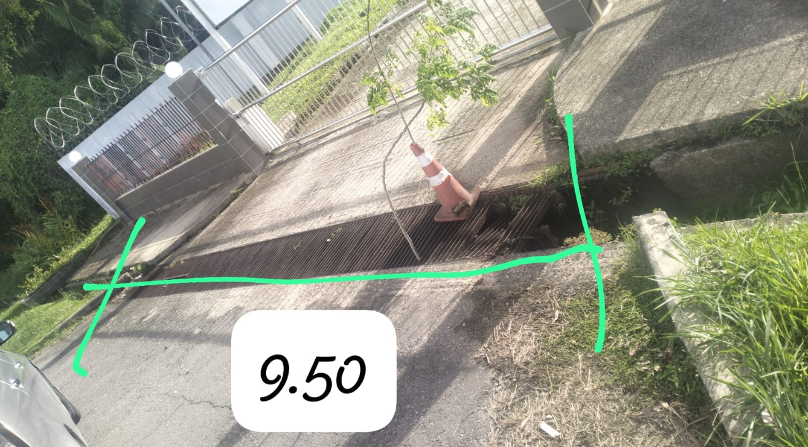

**750mm x 9500mm**

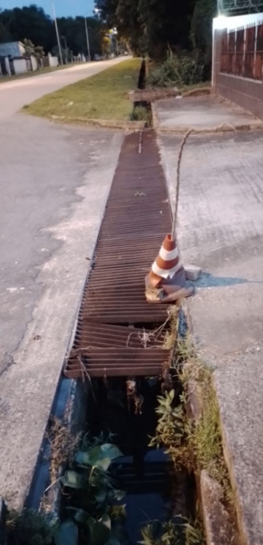

**Exit gate area**