|  |  |  |
| --- | --- | --- |
| **REQUEST FOR QUOTATION (RFQ)** | | Supplier’s Stamp/Signature: |
| Closing Date | : **15 APRIL 2024** |
| Email Submission | : **box1@belts.com.bn** |
| BELTS Ref | : **BELTS/HRA/RFQ/2024/025** |
| Date of Submission | : Click here to enter text. |
| Supplier/Quote Ref | : Click here to enter text. |

|  |  |
| --- | --- |
| Company Name | **Click here to enter text.** |
| Address | **Click here to enter text.** |
| Phone | Office: **Click here to enter text.** Mobile: **Click here to enter text.** |

|  |  |  |  |  |  |
| --- | --- | --- | --- | --- | --- |
| **No.** | **Item Description** | **Delivery Period** | **Qty/UoM** | **Unit Price** | **Total Price** |
| **1** | **PROVISION OF PAVILION DESIGN & CONSTRUCTION SERVICES**  **DESCRIPTION**  DESIGN: PAVILION STYLE  SIZE : 27 METRES x 3 METRES PER SIDE (ESTIMATED)  REFER TO ATTACHMENT AS DESIGN CONCEPT REFERENCE  **DESIGN ELEMENTS**   1. L-SHAPED LAYOUT. 2. MAIN FEATURED BOOTH MEASURING APPROX 6M X 3M TO INCLUDE:    * + - TV (MIN. SIZE OF 55’) X 1        - RECEPTION COUNTER WITH CORPORATE LOGO        - SEATING / DISCUSSION AREA        - MINI STORAGE AREA 3. MINI BOOTH FOR 20 SHOWCASES ALONG THE PERIMETER. MINI BOOTH TO INCLUDE;    * + - TV (MAX SIZE OF 32’) X 1        - RECEPTION COUNTER        - SEATING X 2        - MINI STORAGE AREA 4. ONE STORAGE ROOM INCORPORATED INTO DESIGN.   **COLOR SCHEME:**  PRIMARY COLOR: WHITE.  SECONDARY COLOR: #0f2852.  **LOCATION:**  PENANJONG CAMP GYM, TUTONG.  **BOOTH CONSTRUCTION MILESTONES:**   * BOOTH BUILD UP START : 02 MAY 2024 * BOOTH BUILD UP COMPLETED: 25 MAY 2024   **NOTE:**  KINDLY REFER TO **ATTACHMENT 1** FOR YOUR PERUSAL.  . | **3 WEEKS** | **1 LOT** | **Click here to enter text.** | **Click here to enter text.** |

|  |  |  |
| --- | --- | --- |
| **MANDATORY**  Suppliers are to provide with the Packaging Dimension, Measurement & Weight - in Standard measurement in Meter, Feet, Inches, Cm, Mm, Kg, GM | **TOTAL PRICE** | **Click here to enter text.** |
| Freight Term (EXW,CIF,ETC) | | **Click here to enter text.** |
| Freight Charges (IF APPLICABLE) | | **Click here to enter text.** |
| Any other charges please state | | **Click here to enter text.** |
| **GRAND TOTAL** | | **Click here to enter text.** |

|  |  |
| --- | --- |
| Currency Code : | **BND** |
| Price Validity  (Minimum 9 Months) : | **Click here to enter text.** |
| Payment Terms : | **30 DAYS CREDIT** |
| Warranty : | **Click here to enter text.** |
| Mode of Delivery : | **Click here to enter text.** |
| Delivery Period : | **Click here to enter text.** |
| Country of Manufactured : | **Click here to enter text.** |
| Remarks: | **Click here to enter text.** |

**ATTACHMENT 01**

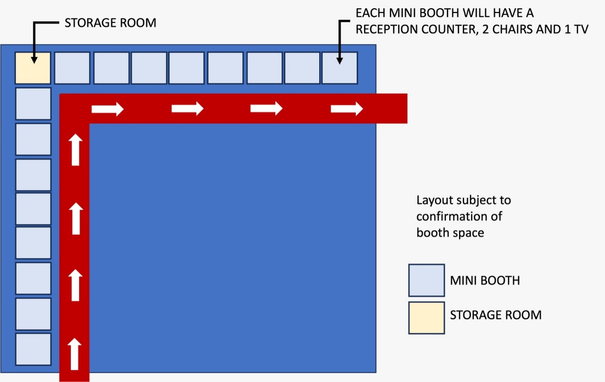

**27 m**

**3 m**

