|  |  |  |
| --- | --- | --- |
| **REQUEST FOR QUOTATION (RFQ)** | | Supplier’s Stamp/Signature: |
| Closing Date | : **06th MARCH 2024** |
| Email Submission | : **box3@belts.com.bn** |
| BELTS Ref | : **BELTS/HRA/RFQ/2024/019** |
| Date of Submission | : Click here to enter text. |
| Supplier/Quote Ref | : Click here to enter text. |

|  |  |
| --- | --- |
| Company Name | **Click here to enter text.** |
| Address | **Click here to enter text.** |
| Phone | Office: **Click here to enter text.** Mobile: **Click here to enter text.** |

|  |  |  |  |  |  |
| --- | --- | --- | --- | --- | --- |
| **No.** | **Item Description** | **Delivery Period** | **Qty/UoM** | **Unit Price** | **Total Price** |
| **1** | **Scope of work:**   * To provide and install bird spikes to the beams between **Zone 1**, **Zone 3** and **Zone 4** (End to End). * To supply scaffolding.   **Location:**  BELTS Engineering Services (ES)  Lot 11 & 12, Spg 557,  Tapak Perindustrian Kg Salar,  Jalan Muara.  **Note:**  Kindly refer to **Attachment 1** for your perusal. | **1-3 WORKING DAYS UPON PURCHASE ORDER (PO) ISSUANCE.** | **1 LOT** | **Click here to enter text.** | **Click here to enter text.** |
| **2** | **Scope of work:**   * To provide and install bird spikes to the beams of the **workshop area**. * To supply scaffolding.   **Location:**  BELTS Engineering Services (ES)  Lot 11 & 12, Spg 557,  Tapak Perindustrian Kg Salar,  Jalan Muara.  **Note:**  Kindly refer to **Attachment 2** for your perusal. | **1 LOT** | **Click here to enter text.** | **Click here to enter text.** |

|  |  |  |
| --- | --- | --- |
| **MANDATORY**  Suppliers are to provide with the Packaging Dimension, Measurement & Weight - in Standard measurement in Meter, Feet, Inches, Cm, Mm, Kg, GM | **TOTAL PRICE** | **Click here to enter text.** |
| Freight Term (EXW,CIF,ETC) | | **Click here to enter text.** |
| Freight Charges (IF APPLICABLE) | | **Click here to enter text.** |
| Any other charges please state | | **Click here to enter text.** |
| **GRAND TOTAL** | | **Click here to enter text.** |

|  |  |
| --- | --- |
| Currency Code : | **BND** |
| Price Validity  (Minimum 9 Months) : | **Click here to enter text.** |
| Payment Terms : | **30 DAYS CREDIT** |
| Warranty : | **Click here to enter text.** |
| Mode of Delivery : | **Click here to enter text.** |
| Delivery Period : | **Click here to enter text.** |
| Country of Manufactured : | **Click here to enter text.** |
| Remarks: | **Click here to enter text.** |

**ATTACHMENT 1:**

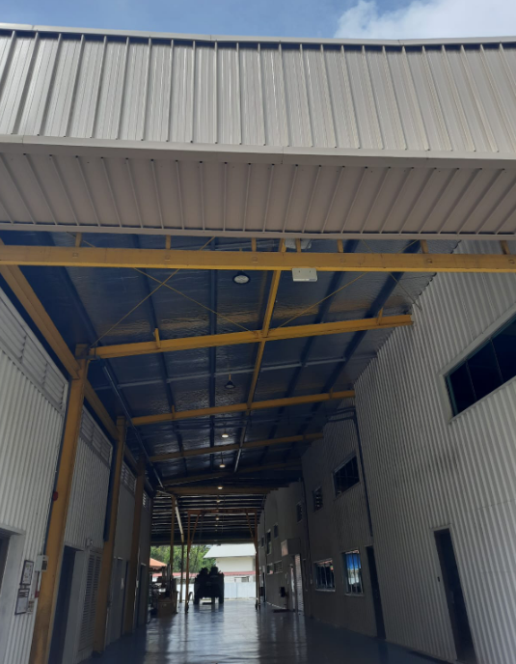

**Left is (Zone 1) and right is (Zone 3 and Zone 4). To install from here straight onto the end of the other side.**

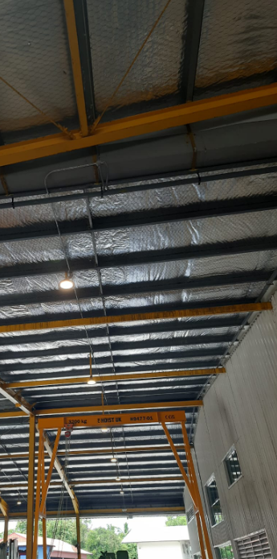

**ATTACHMENT 2**

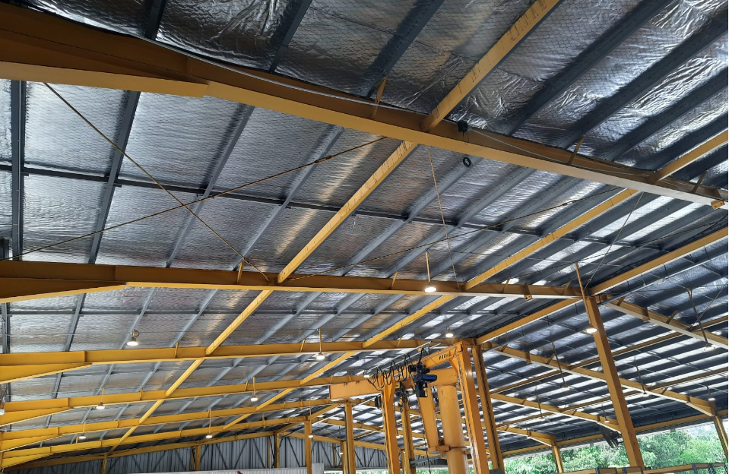

**Workshop area.**

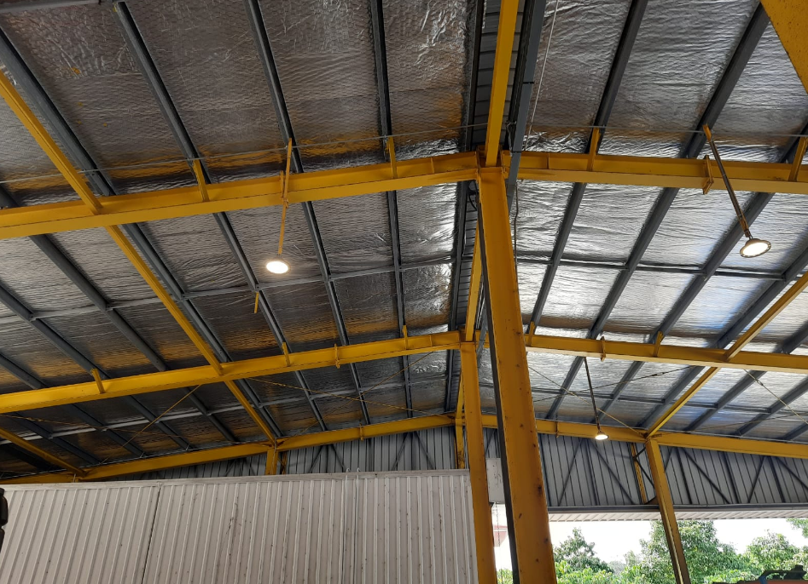

**Workshop area**