|  |  |  |
| --- | --- | --- |
| **REQUEST FOR QUOTATION (RFQ)** | | Supplier’s Stamp/Signature: |
| Closing Date | : **26February 2024** |
| Email Submission | : **box6@belts.com.bn** |
| BELTS Ref | : **BELTS/HRA/RFQ/2024/018** |
| Date of Submission | : Click here to enter text. |
| Supplier/Quote Ref | : Click here to enter text. |

|  |  |
| --- | --- |
| Company Name | **Click here to enter text.** |
| Address | **Click here to enter text.** |
| Phone | Office: **Click here to enter text.** Mobile: **Click here to enter text.** |

|  |  |  |  |  |  |  |  |
| --- | --- | --- | --- | --- | --- | --- | --- |
| **No.** | **Item Description** | **Delivery Period** | **Qty/UoM** | **Unit Price** | | **Total Price** | |
| **1** | **TO STEAM CLEAN BRIEFING HALL CARPET AND CHAIRS AT BELTS TRAINING SIMULATION CENTRE (TSC), PENANJONG GARRISON, TUTONG.**  **To steam clean and remove any visible stains of the Briefing Hall’s carpets.**    Kindly refer to **Attachment 1** below for your perusal. | **1-3 WORKING DAYS UPON ISSUANCE OF PURCHASE ORDER** | **1 LOT** | **Click here to enter text.** | | **Click here to enter text.** | |
| **2** | **To steam clean and remove any visible stains of the Briefing Hall’s chairs.**    Quantity  **100 units.**  Kindly refer to **Attachment 2** below for your perusal. | **1 LOT** | **Click here to enter text.** | | **Click here to enter text.** | |
| **MANDATORY**  Suppliers are to provide with the Packaging Dimension, Measurement & Weight - in Standard measurement in Meter, Feet, Inches, Cm, Mm, Kg, GM | | | **TOTAL PRICE** | | **Click here to enter text.** | |
| Freight Term (EXW,CIF,ETC) | | | | | **Click here to enter text.** | |
| Freight Charges (IF APPLICABLE) | | | | | **Click here to enter text.** | |
| Any other charges please state | | | | | **Click here to enter text.** | |
| **GRAND TOTAL** | | | | | **Click here to enter text.** | |

|  |  |
| --- | --- |
| Currency Code : | **BND** |
| Price Validity  (Minimum 9 Months) : | **Click here to enter text.** |
| Payment Terms : | **30 DAYS CREDIT** |
| Warranty : | **Click here to enter text.** |
| Mode of Delivery : | **Click here to enter text.** |
| Delivery Period : | **Click here to enter text.** |
| Country of Manufactured : | **Click here to enter text.** |
| Remarks: | **Click here to enter text.** |

**ATTACHMENT 1: BRIEFING HALL**

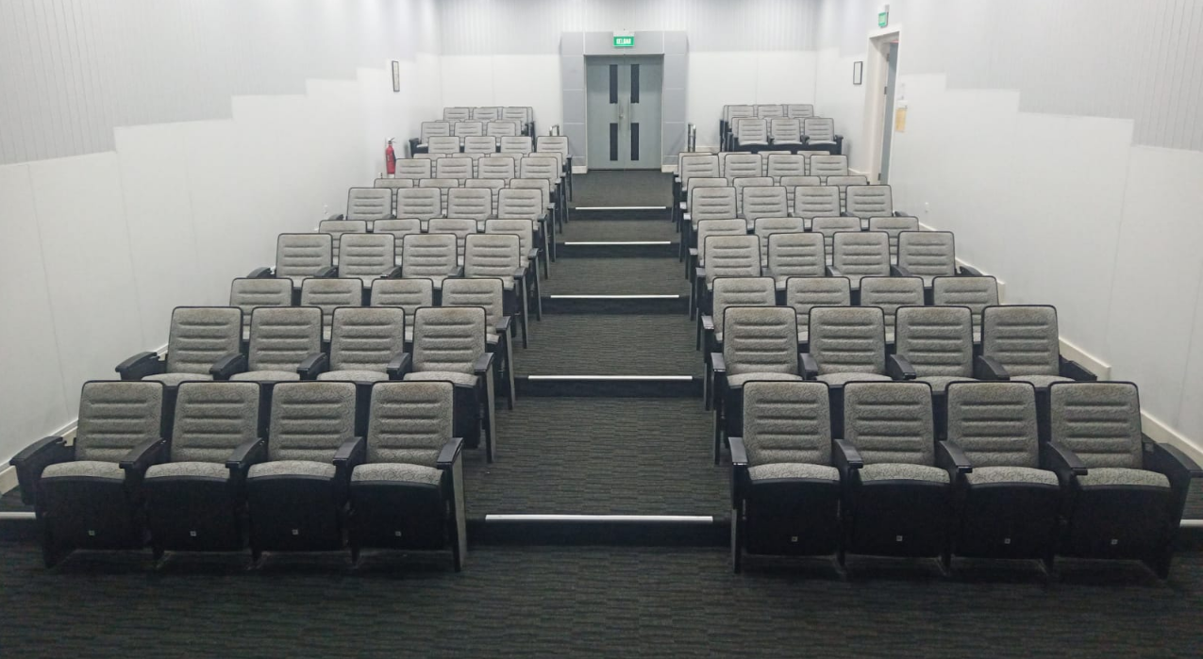

**ATTACHMENT 2: BRIEFING HALL CHAIRS**

